Office of Maritime Communications

Observation Check List 2017 –
Suggested Responses - Long Range Operator Certificate of Proficiency (LROCP)

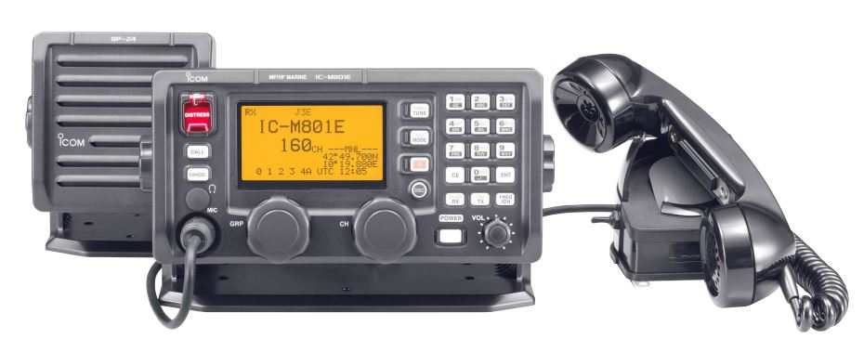
 | Assessment Criteria | Suggested Expected Response
1 | Using the MF/HF and VHF marine radio demonstrate:  - Turn on transceiver;  - Adjust for volume;  - Tune receiver (VHF – n/a);  - Set channel for initial call; and  - Reduce background noise. | Turn on and adjust volume.  Tune receiver (tune button).  Frequency 2182kHz using channel button.  Turn mute control on/off.
2 | Using the MF/HF and VHF marine radio demonstrate:  - How to log in with Sea Rescue Fremantle.  - Call;  - Response;  - Changing channels; and  - Signing off.  Sugar Pie (x3) this is Sea Rescue Fremantle (x 3) received change to 2524 over.  Sugar pie this is Sea Rescue Fremantle received loud and clear go ahead. Over.  Sugar pie this is Sea Rescue Fremantle, received, heading for Ninth Island estimated time of return 5:00pm.  Out. | On frequency 2182kHz state:  Sea rescue Fremantle (X 3)  this is  Sugar pie (x 3) (call sign) logging in suggest change to 2524 Over  (both stations change to 2524)  Sea Rescue Fremantle this is Sugar Pie on 2524 how do you read me? over  Sea Rescue Fremantle this Sugar Pie heading for Ninth Island estimate of return 5:00pm. Over  The transceiver should then be set back to 2182kHz.

3 | Using either marine radio demonstrate:  - A mayday call and message. | Mayday Mayday Mayday this is Sugar Pie Sugar Pie  Mayday Sugar Pie, position, nature of distress and then any other information ie number people on-board, EPIRB activated ect. Over
4 | Using either marine radio demonstrate:  - Simulate a (do not press button) DSC distress alert. | Open cover on DSC red button tap once. Display will appear on screen. Scroll through the category screen to defined the various categories ie position (if no GPS) number of people on board, nature of distress ect.  To send the distress open cover and hold red button down for 5 seconds a counter will beep and then the alarm will sound.
5 | Using the VHF marine radio demonstrate:  - Set a channel for dual watch. | Program a working channel into the marine radio and then tap the dual watch button.

